3 Day Lacrosse Clinic

Hosted by Pope John Paul Varsity Captain Justin Kent

-- 4 year Varsity Starter 3 Year Varsity Captain –

Ready to Take it to the Next Level?
Join us July 31st, August 1st and 2nd
9am-12pm all 3 days
Cost: 125$ per player, Ages 6-13

For more info contact:
Justin Kent 484-988-0143 and/or
ASC GM Tom Iannella 215-353-1566

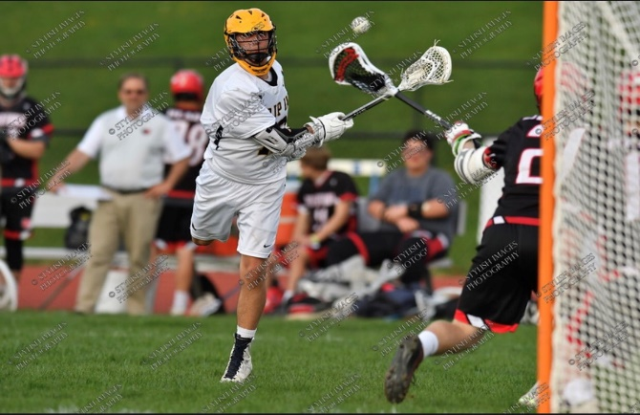

Asc Lax Clinic Registration/ Waiver Form
Players name:____________________________
Address:____________________________________________________
City:____________________________________
State:_______________ ZIP:_________________
Age:______ Date of Birth:_________________________
Parent name:______________________
Parent cell:________________________
Emergency contact:____________________________
Email address:________________________________
I hereby indicate that I am the parent and/or legal guardian of ____________________________________________________________. I give my child permission to participate in any/all activities related to the aforementioned organization/program at All Sports Center at Upper Providence (ASC). I am in agreement with all of the terms of this Waiver & Release Form, and I maintain the authority to enter into this Waiver & Release on behalf of my child, myself, and all legal parties/guardians of my child.
I acknowledge that some activities in which my child may participate at ASC have certain dangers. Accidents may occur, he/she could sustain injuries, or even die as a result of these risks. Property damage may also occur as a consequence. Acknowledging these risks, I hereby knowingly and voluntarily assume all risk of injury on my child's behalf while he/she is participating in the activities at ASC. Understanding the inherent risks in participating, I affirm, to the best of my knowledge, that my child has no medical, physical, and/or emotional health conditions which would hinder his/her participation. I certify that my child is physically fit, has been sufficiently trained to participate in this activity, and has not been advised otherwise.
In consideration of my request and permission for my child to participate in any/all activities at ASC, I hereby agree to release and forever discharge All Sports Center at Upper Providence, their heirs, and executors from any and all liability for injuries, death or property damage, arising or resulting from, or any other way connected with, my child's participation. The term of this Waiver & Release applies to myself, my child, our heirs, executors, administrators, assigns, successors, spouse, personal representatives, agents, legatees, other parents, and/or legal guardians of my child, and all family members. I agree that this Waiver & Release shall cover my child's participation in any/all activity, including but not limited to, practice or instructional sessions, any activity directly taught by the coach or league representatives, as well as programs directed by ASC staff members.
I agree to indemnify or hold All Sports Center at Upper Providence harmless from any/all liability arising out of, whether directly or indirectly, my child's involvement or participation in activities at ASC including but not limited to attorney's fees, whether paid by ASC or a carrier on behalf of ASC, costs, or any liability which may arise out of my child's involvement or participation in any/all activities conducted on ASC property.
I give permission to All Sports Center at Upper Providence to obtain on my child's behalf, any emergency treatment. In case of sickness, accident, illness or injury, ASC has my express permission to secure such medical attention as is deemed necessary in the sole discretion of ASC.
All Sports Center in Upper Providence has my permission to use my or my child’s photograph publicly to promote the facility. This waiver gives ASC permission to use photographs and/or video recordings of any events that takes place on ASC property. I understand that the images may be used in print publications, online publications, presentations, websites, and social media. I also understand that no royalty, fee or other compensation shall become payable to me by reason of such use. I waive the right to approve the final product. I agree that all such portraits, pictures, photographs, video and audio recordings, and any reproductions thereof, and all plates, negatives, recording tape and digital files are and shall remain the property of ASC. I hereby release, acquit and forever discharge ASC from any and all claims, demands, rights, promises, damages and liabilities arising out of or in connection with the use or distribution of said photographs and/or video recordings, including but not limited to any claims for invasion of privacy, appropriation of likeness or defamation
I have read and understand all of the information presented to me in this Waiver & Release Form and understand the terms and agreement. Lastly, I agree to accept and abide by the rules and regulations of the programs, coaches and/or referees, and the ASC facility itself..
Parent Signature: ____________________________________________________ Date:__________________

Itinerary
Day 1
- Stretches/ Warm Up
- Passing and Catching
- 1 vs. 1
- 2 vs. 2
- Fast breaks
- Dodging and Defensive
- Scrimmage
Day 2
- Warm Up
- Offensive and Defensive breakdown
- Footwork/ Speed
- Stick Skills
- Shooting
- Man Up offense/ Man Down defense
Day 3
- Warm Up
- Shooting Drills
- Team offensive
- Quick stick passing
- 6 vs. 6
- Scrimmage
- STICK TRICK COMPETITION!!!

